**Submission Instructions:**

Your submission for this activity should be a Word document that includes the following screenshots, each labeled for the step that the screenshot represents:

1. Provide a screenshot to show that you have the Bitnami *containers* up and running.

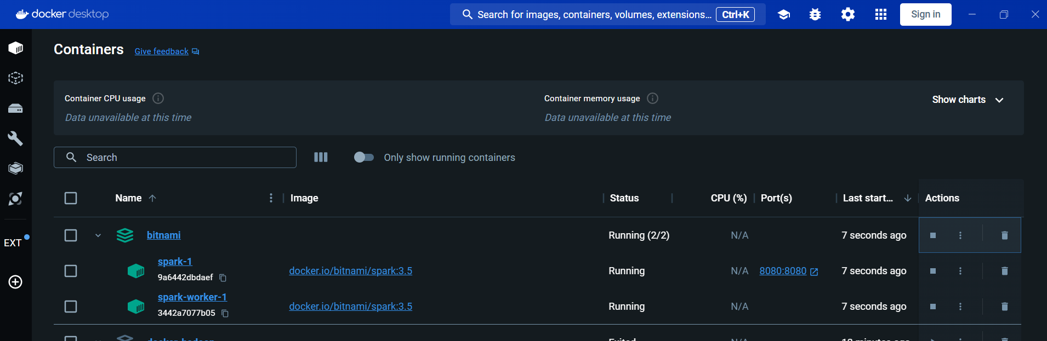

1. Provide a screenshot to show that the departuredelays.csv file is in the root folder.

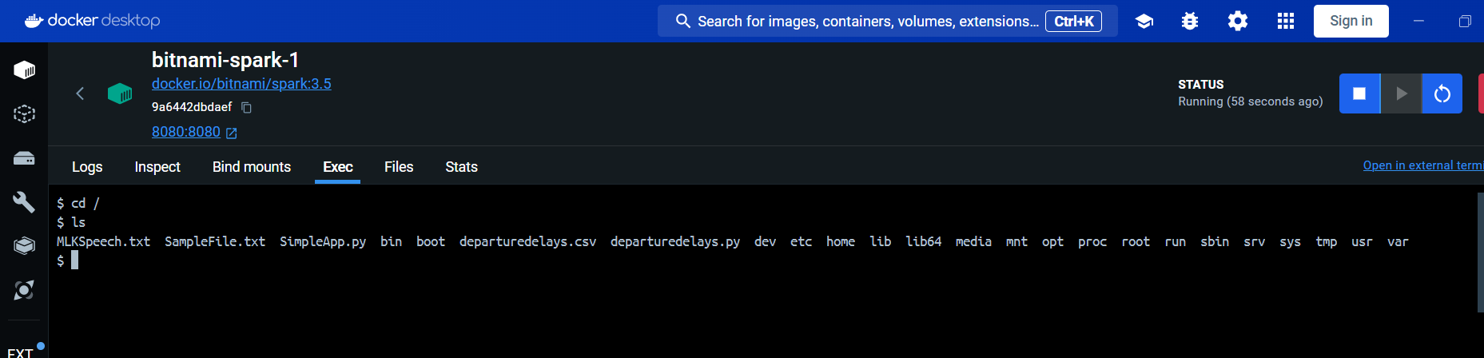

1. Provide a screenshot to show that you successfully opened PySpark.

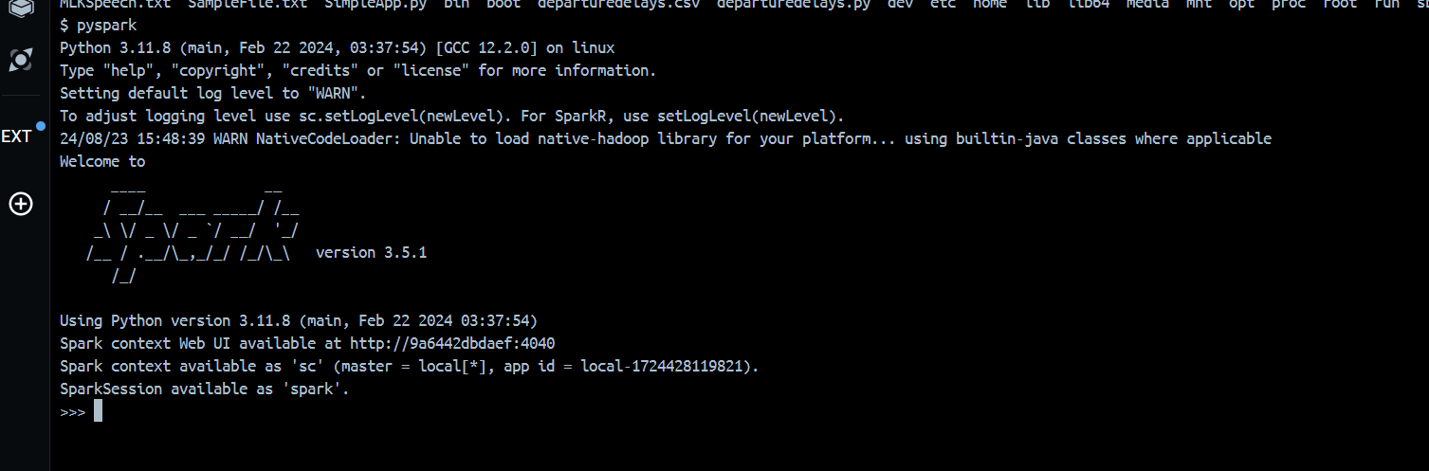

1. Provide a screenshot to show that you successfully started a PySpark session.



1. Provide a screenshot to show that you successfully defined the spark PySpark session.

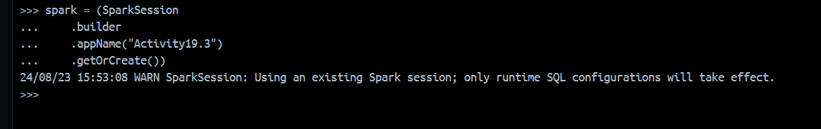

1. Provide a screenshot to show that you successfully defined the activity19_3_data variable.

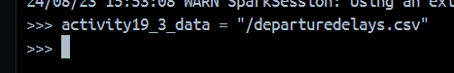

1. Provide a screenshot to show that you successfully defined the df *dataframe*.

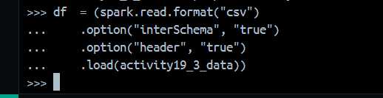

1. Provide a screenshot to show that you successfully created a view of the *dataframe* that is named activity19_3_table.

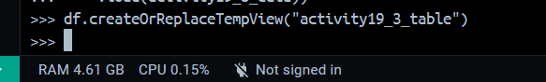

1. Provide a screenshot to show that you selected the correct entries from your data. Your data should display the first 10 flights from JFK to SEA that had a delay of greater than 90 minutes.

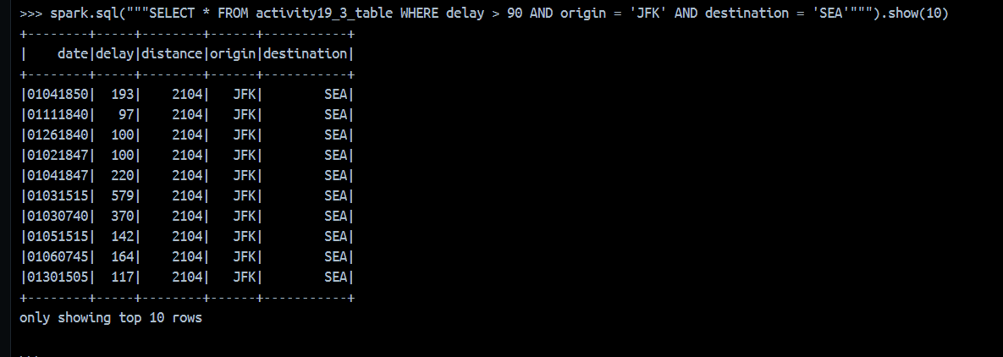

1. Provide a screenshot to show that you selected the correct entries from your data. Your data should display the first five flights from SFO to MIA that had a delay of less than 60 minutes.

